**Module-3 : Docker – I Assignment – 1**

**To Do :**

You have been asked to:

● Pull ubuntu container

● Run this container, and map port 80 on the local

● Install apache2 on this container

● Check if you are able to access the apache page on your browser

**Solution :**

sudo apt-get update && sudo apt-get install docker.io -y

sudo docker pull ubuntu //Pulling ubuntu image.

sudo docker images //ubuntu image present

**//Running a container and maping it to port 80 :**

sudo docker run –itd –name cont1u -p 80:80 ubuntu

sudo docker ps

//CONTAINER ID IMAGE COMMAND CREATED STATUS PORTS NAMES

f5dda5c1cb99 ubuntu "bash" 40 seconds ago Up 38 seconds 0.0.0.0:80->80/tcp, :::80->80/tcp cont1u //

sudo docker exec –it f5dda5c1cb99 bash //Going inside the container.

**//Installing Apache2**

root@f5dda5c1cb99:/# apt-get update

//updating machine before installing any softawares.

apt-get install apache2 –y //selected area/location and city

Service apache2 status //checking the apache2 service status

service not started, manually starting it :

service apache2 start

service apache2 status //apache2 is running

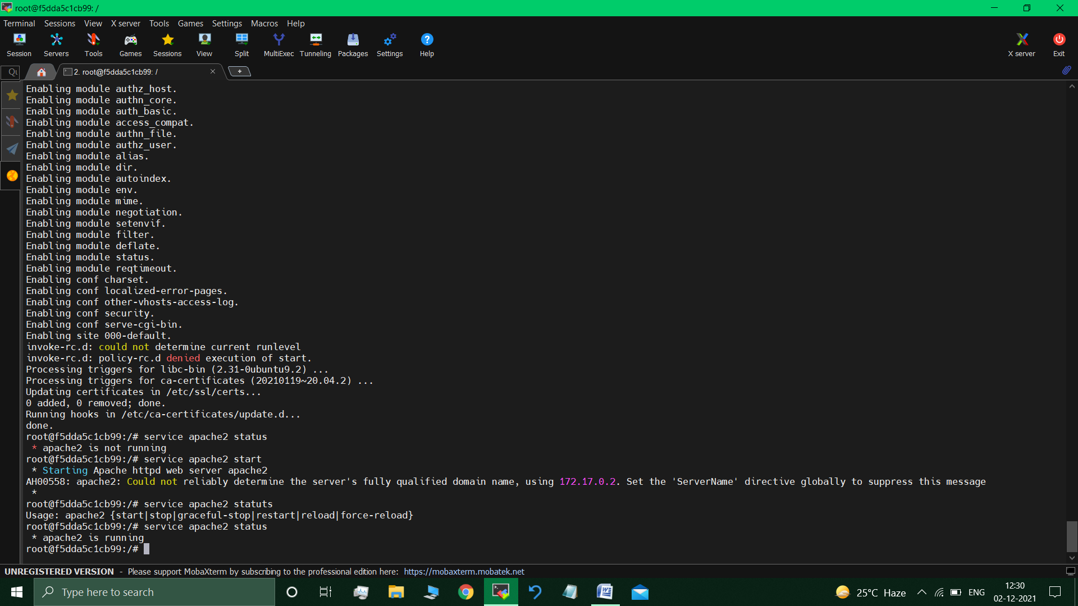

**Mapping the container to run on port 80 :**

Visited the Docker instance > Instance Details > Security >Security Groups >Inbound Rules > Edit Inbound Rules > Added HTTP Type rule (IP4-anywhere).

//http by default has the port range : 80, so selected and added it.

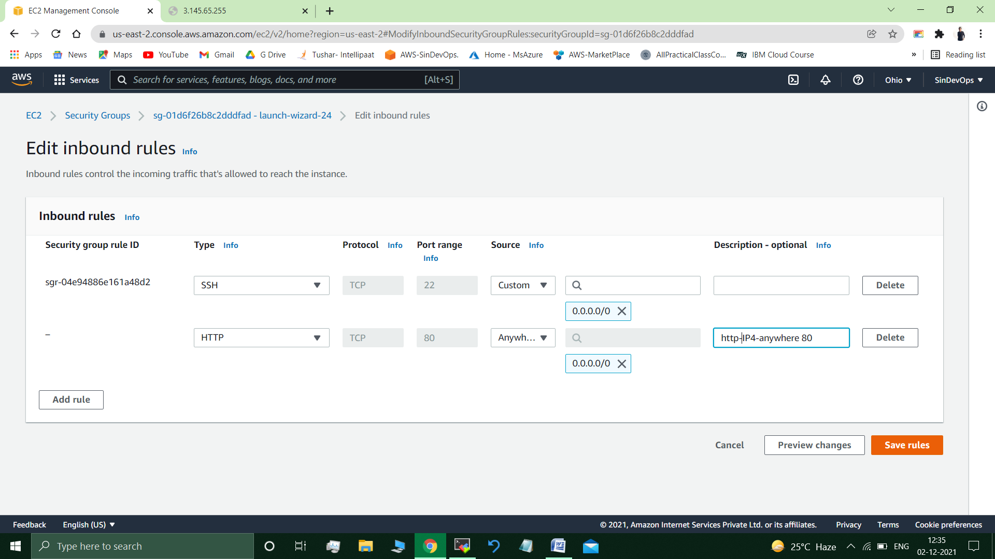

**Checking if we are able to access the apache page on your browser :**

*Google search The Instance’s Public IP Address* **:** <http://3.145.65.255/>

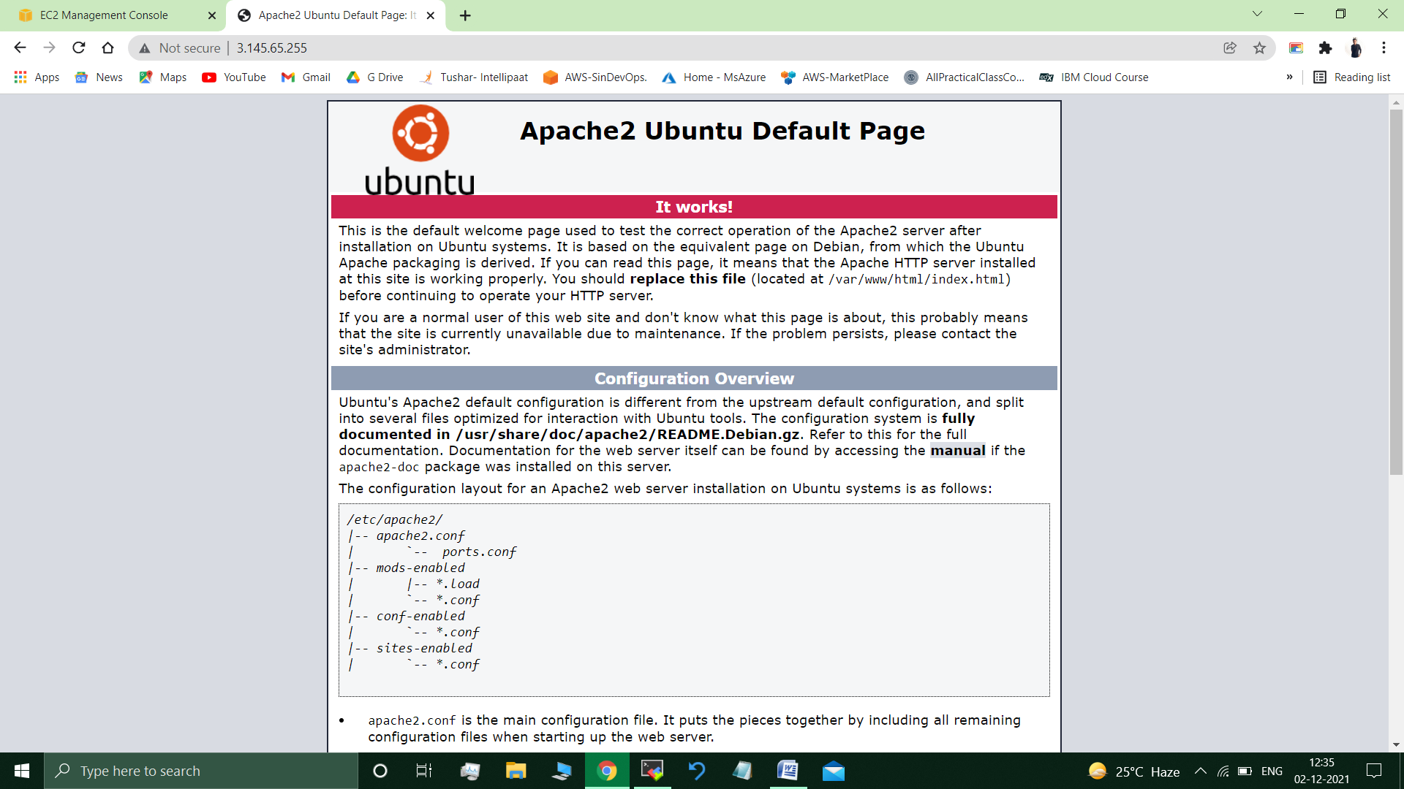

//Apache2 web Page is displayed.

**Submitted By : Tushar Sinha**

**Email ID :** [**sinhatushar17@gmail.com**](mailto:sinhatushar17@gmail.com)

**Enrolled in the “DevOps Architect Master’s Training Program”**